Bobtab: Equipment Sales Flow for Doosan Bobcat

Contents

Work Flow…………………………………………………………………………………………………………………………………….…….2
Getting Started……………………………………………………………………………………………………………………………………3
Attending Sales Visit-Mobile Flow………………………………………………..........................................................4
Meeting Report & Enquiry Generation………………………………………………………………………………………………..7
Sales Manager Web Login (Enquiry Qualification)…………….……………………………………………………………….12
Enquiry Progress update via app & Sale Coordinator Web Login……………………………………………………….15
Enquiry Status Change by Sales Coordinator…………………………………………………………………………………..…16
Capturing Order Lost…………………………………………………………………………………………………………………..…….18
Direct Enquiry Logging By Sales Engineer…………………………………………………………………………………………..20

Work Flow for Equipment Sales:

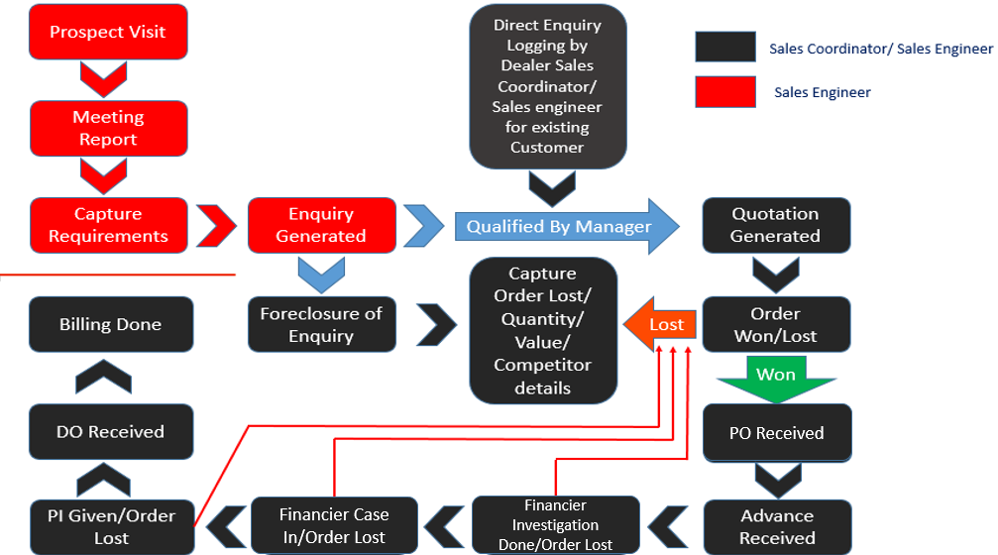

Any mobile user can download Bobtab app from Google Play Store or App store (iOS). Logo for the Bobtab app will be like below image:
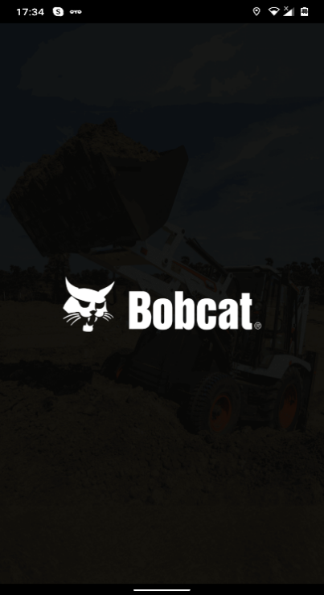
After installation of the app, the user needs to share the device id (highlighted with orange color at the bottom) to OEM Coordinator to enable the access and this device id is unique for individual users. Once access is given fill the details like Country Code, Username and Password and click on register for registration of the app.
For example:
Username: marwellsa2
Password: *******
Note: All entries should be in small case letters
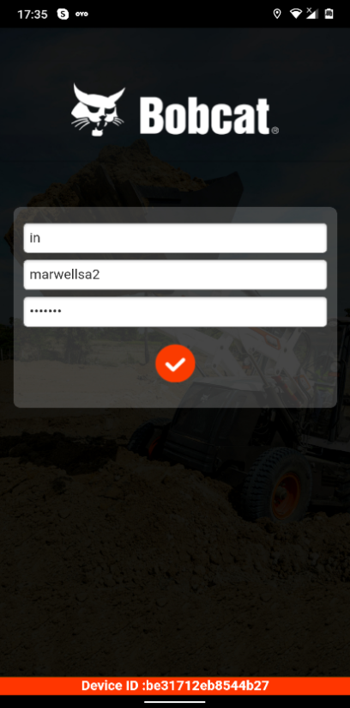

After registration, the Sales engineer can log a Prospect Visit for a new customer from Sales Visit Logging or can generate an enquiry directly from Enquiry Logging.
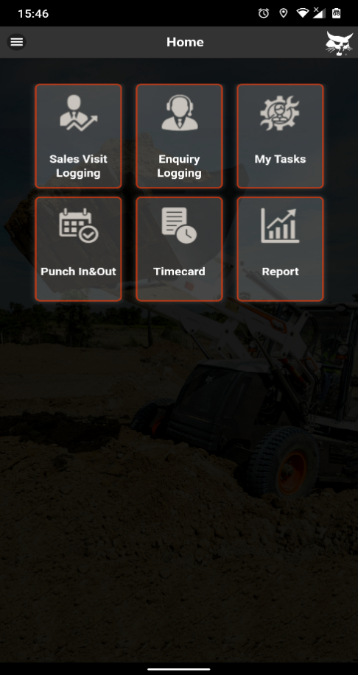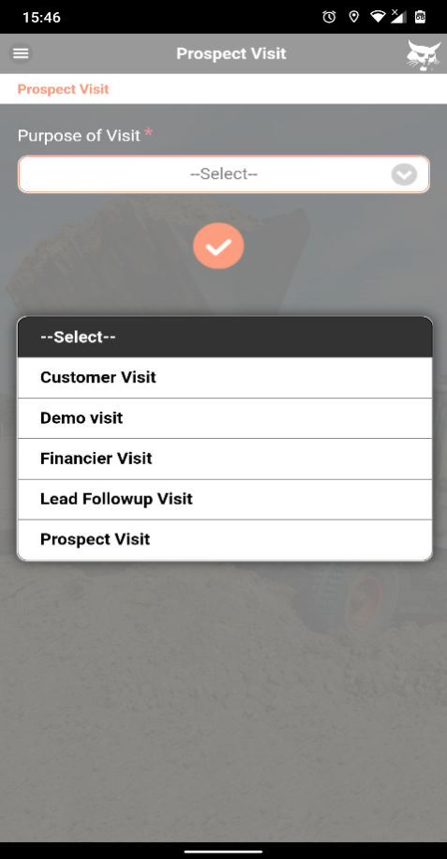
Sales engineer’s needs to fill up the mandatory fields marked with (*).After filling up all necessary information. Then the sales engineer needs to click on Tick button to save. Click on Ok to confirm.
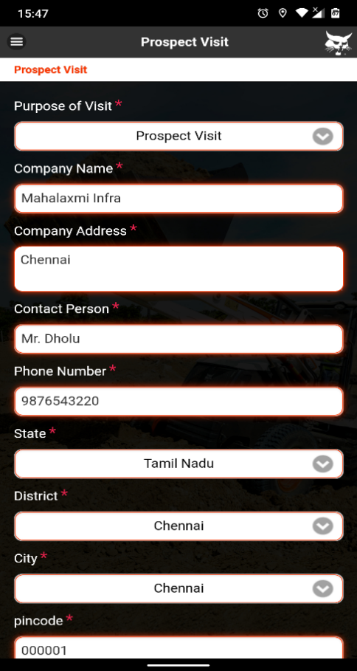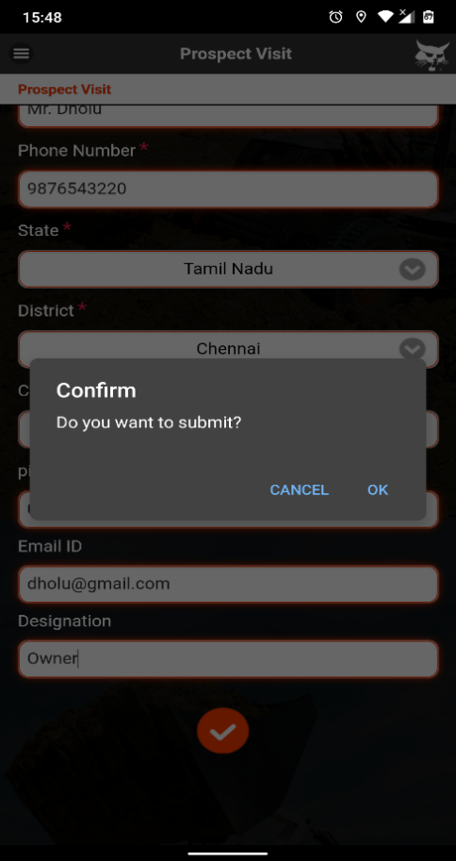

After confirming the submitted details, a Visit number will be generated. The Visit number will start with V for Visit & followed by the dealer short name (Eg: MW for Marwell). Simultaneously, the system will add this customer info in the data base with a unique customer id & that customer id can be used for Direct Enquiry logging either from Sales engineer’s mobile app or from Sales Coordinator’s WEB application.
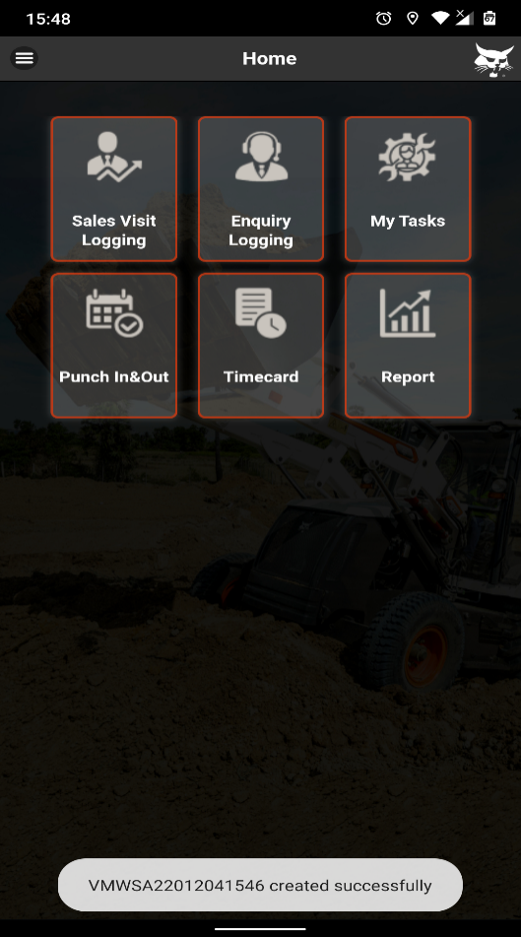
The newly created Visit number will appear under My Tasks. Sales Engineers may need to click on “You have got new updates” to sync the visit.
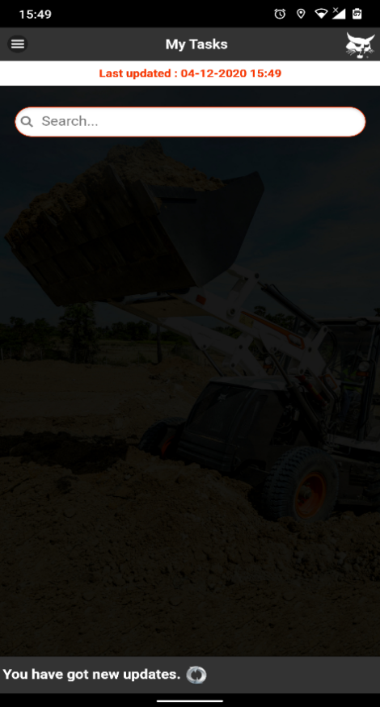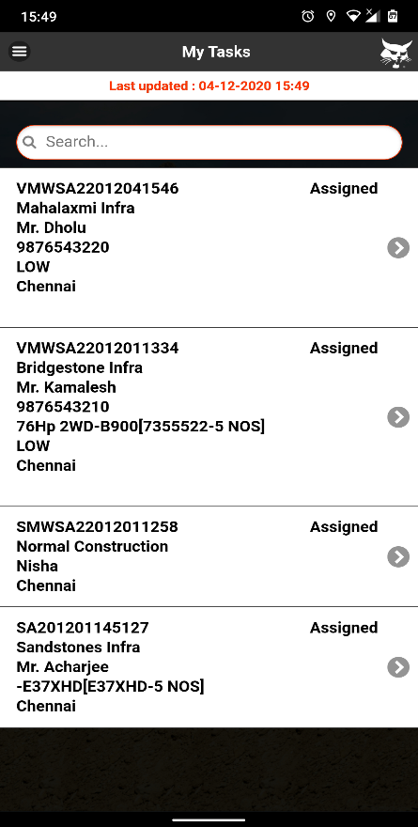

Once the Visit number gets visible in My Task, the sales engineers can do Trip Start by clicking on the visit number. Also they can attach files from the Attach option.
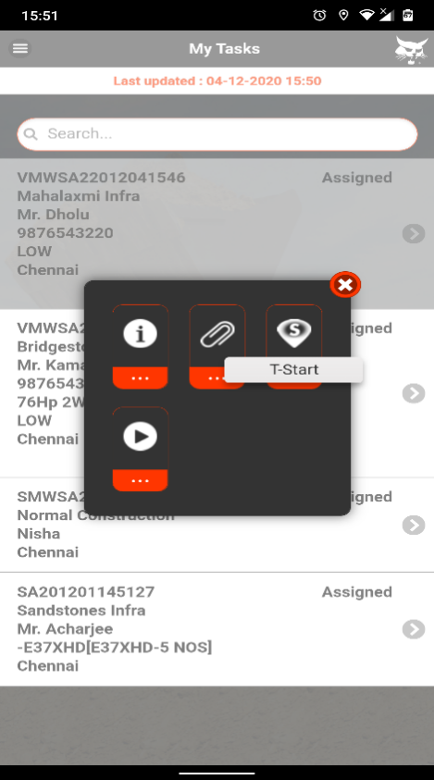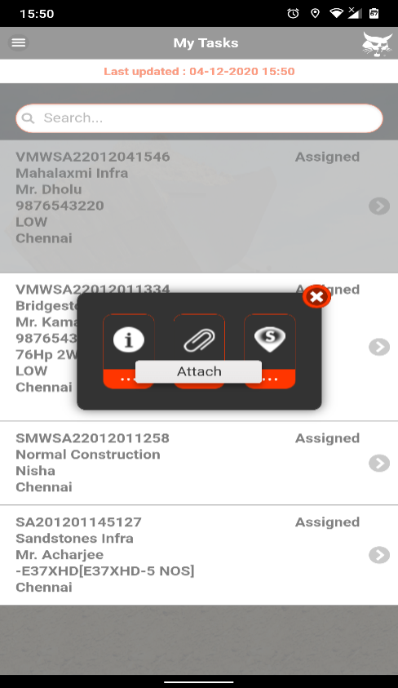

Once the Sales Engineer does Trip Start, the selected visit number will be shown in Green color. After doing the Trip Finish, that visit number will again go back in normal color.
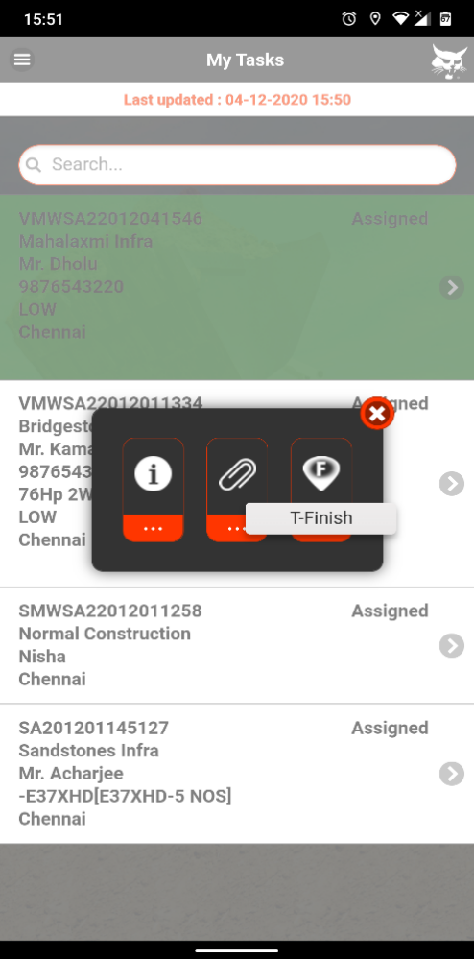
Now the Sales engineer will get option for Meeting Start along with the other three option. Engineer can do Trip Start/Finish multiple times to record their trip details if there is a break journey.
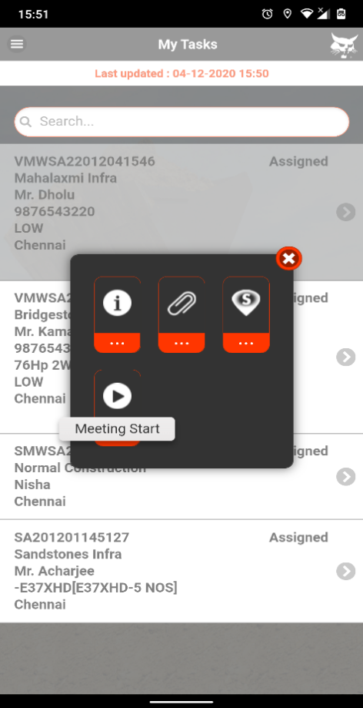
After reaching to the prospect customer, Engineer can do Meeting Start to start the meeting. Once the engineer does the Meeting Start, the Visit number will again go back in Green color & the app will not allow the sales engineer to proceed for another visit. During the meeting, the sales engineer can note down the customer’s requirements in Meeting Report by clicking on that visit.
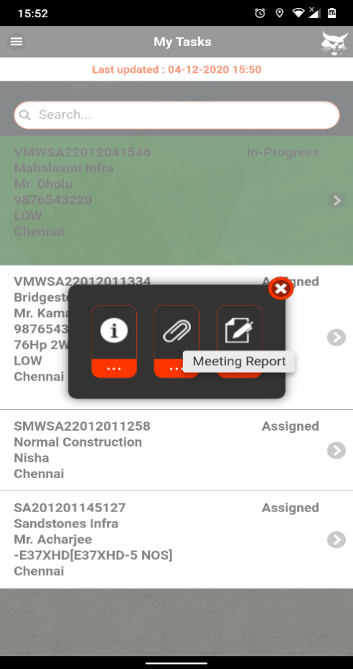
The Sales engineers need to fill up all the required information marked with (*) & also record their location by clicking on Tag My Meeting Location. After clicking on Tag Location, the app will fetch location from the Google Map. The arrows located in the middle will help engineers to surf through the Previous & Next pages. And the outer arrows will help engineers to directly go the first & last pages.
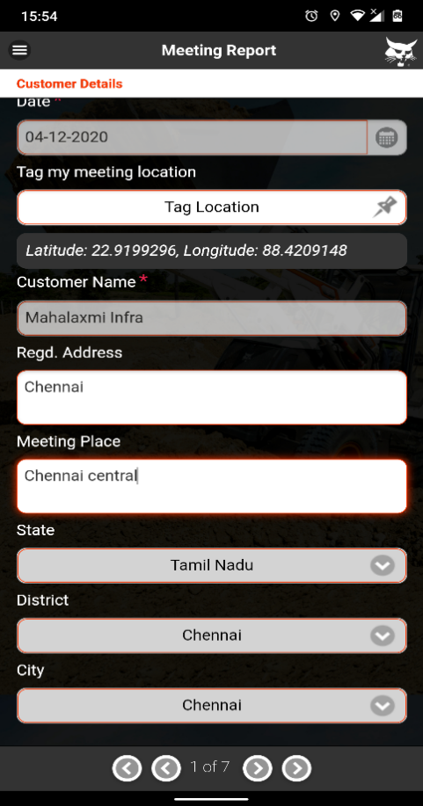
If there are multiple contact persons then sales engineers can generate a new field by clicking on (+) button below.
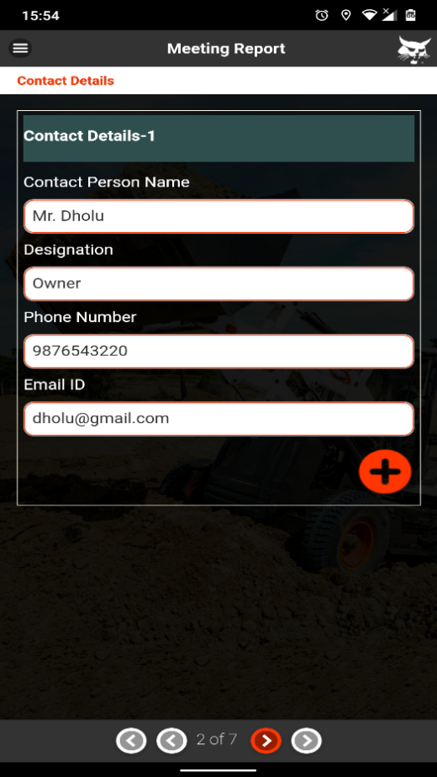

Then the engineers can capture the existing fleet list of the prospect if the similar machine is available to the customer. Then sales engineers need to select the Equipment Category from the dropdown. If the customer has some existing fleets then that can be added one by one. By clicking on (+) button, a new field will appear.
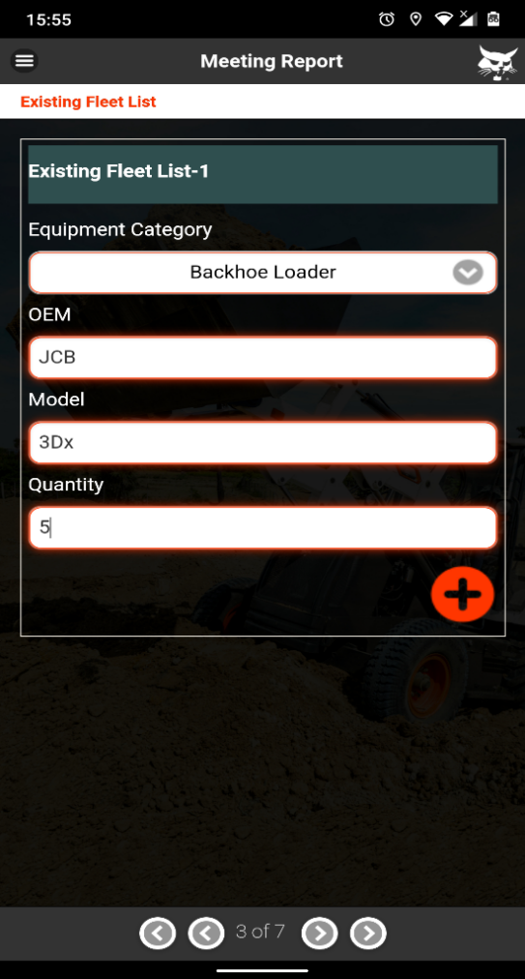
There is a delete option if there is some mistake happened while entering existing fleet details. The sales engineer need to select the Customer Type & Customer Segment from dropdown. Multiple segments can be selected from dropdown.
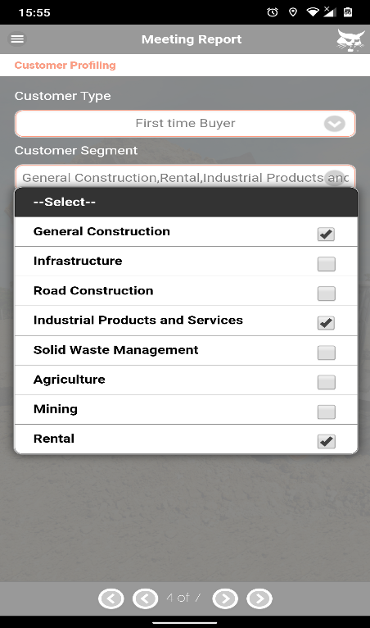
The Sales Engineer needs to collect the Financier Details from the drop down. There is a flip switch given to enable Doosan Bobcat Finance (DB Finance)
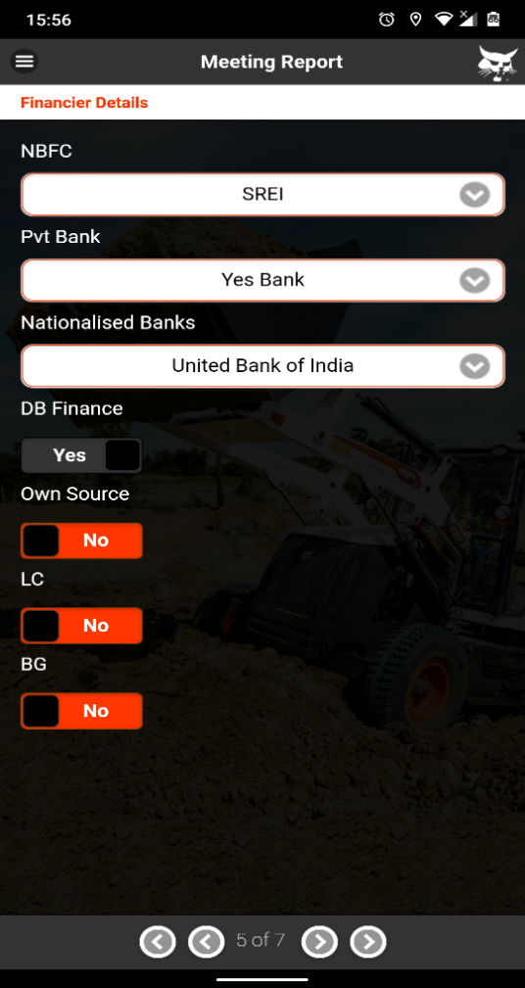
Now, the sales engineer will capture the customer’s requirement. Sales engineers also can add more than one machine by clicking on (+) button if required by the customer.
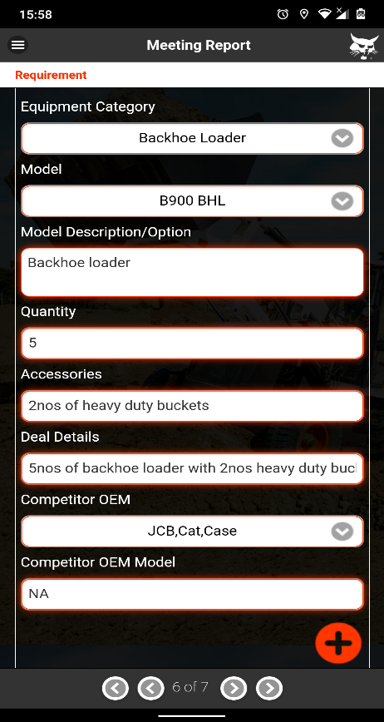

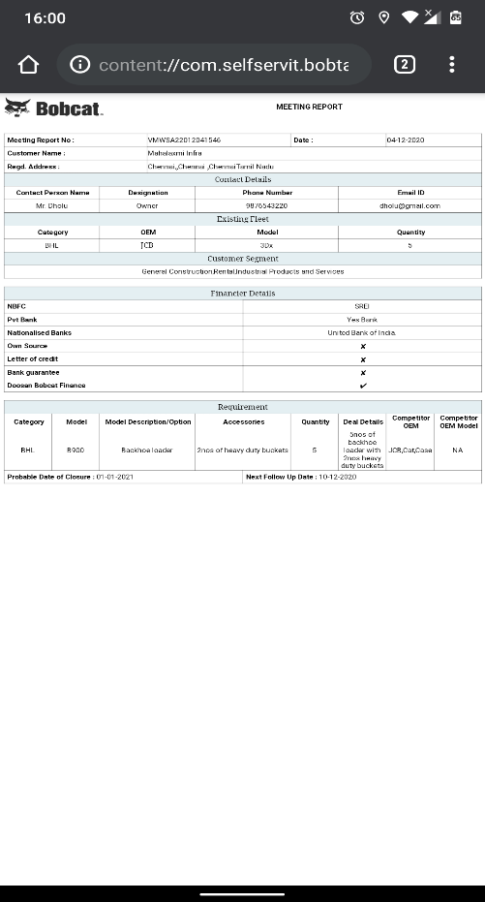
Then the sales engineer needs to enter the next follow-up date & a probable date of closure of the deal. By clicking on the “EYE” button, the sales engineer can verify the information which he/she has entered in the meeting report before submission. The visit report preview will be shown in .html format & user also can select HTML viewer/ any web browser to view the same. After verifying all of the information, sales engineers can submit the visit report by clicking on Submit button. And by clicking on OK, the visit report will get submitted.

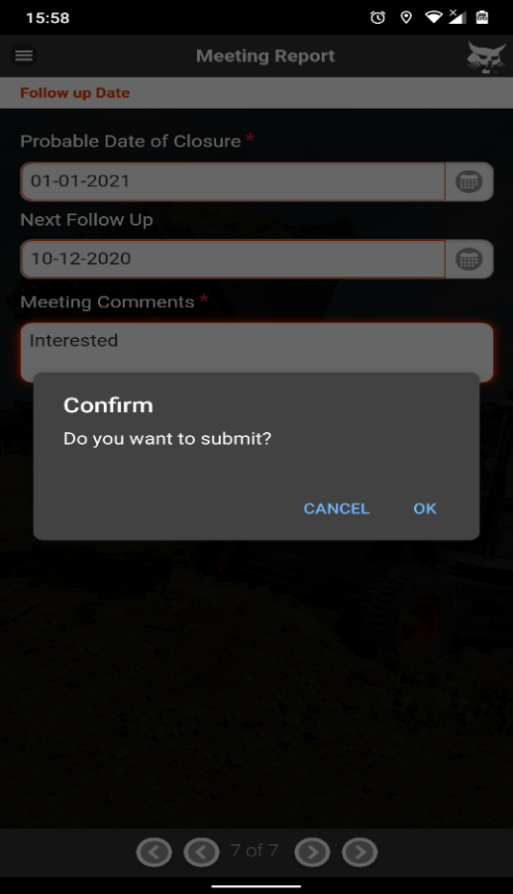

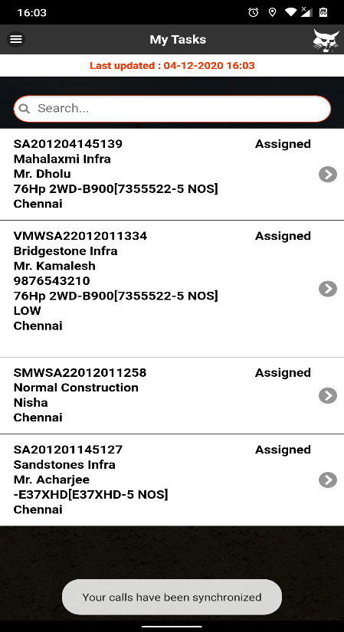
Now the visit number will be shown in Complete status under My Tasks. As soon as visit completed, the Enquiry(‘s) will be created automatically as per requirement captured in the Meeting Report and will be assigned to same engineer. The sales engineer may see a notification as “You have got new updates”. By clicking on that notification, the information will get synced in the server & the new Enquiries will be shown in Assigned status starting with SA.
For each type of machines, an individual enquiry will be generated. The newly generated enquiries will be shown in Assign status. The Sales engineers can proceed for the enquiries once the Dealer Sales Coordinator or The Dealer Sales Manager Qualify them from their WEB login.

Now in WEB login, the Sales Manager needs to Qualify the enquiry generated from the Visit option under Equipment. Sales Coordinator/Managers can do web login via their credentials.
The site URL is http://bobcat.mservice.in/
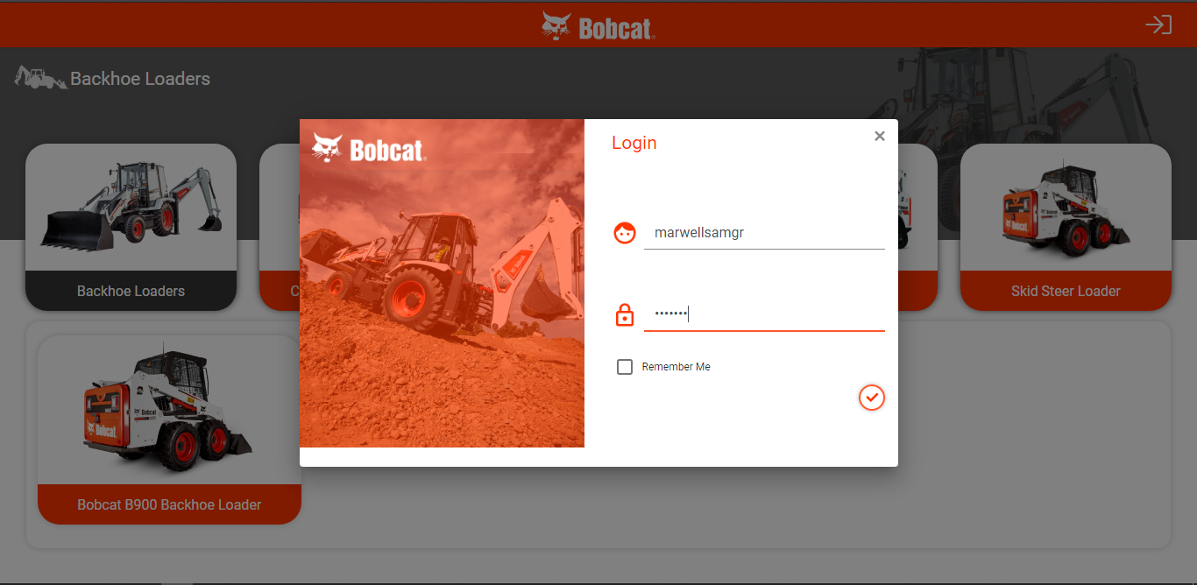

The Sales Manager needs to click on the Enquiry under Equipment menu.
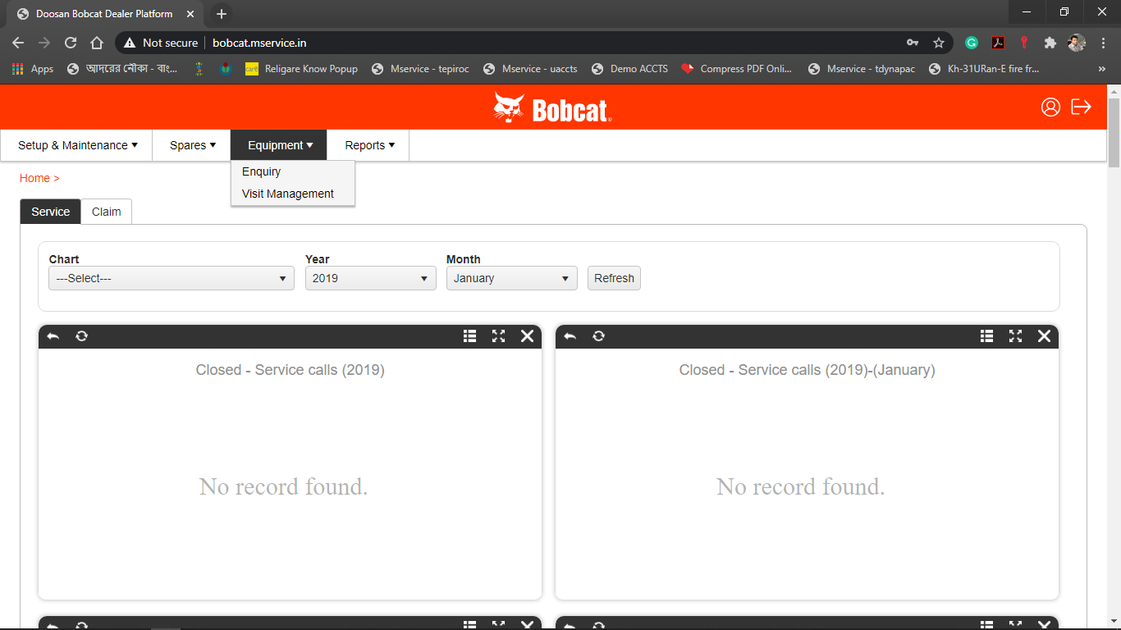
The new Enquiries will be shown in Assigned status starting with SA. The Sales Managers can view the enquiry & click on the Qualify button under Action menu in order to Qualify it.
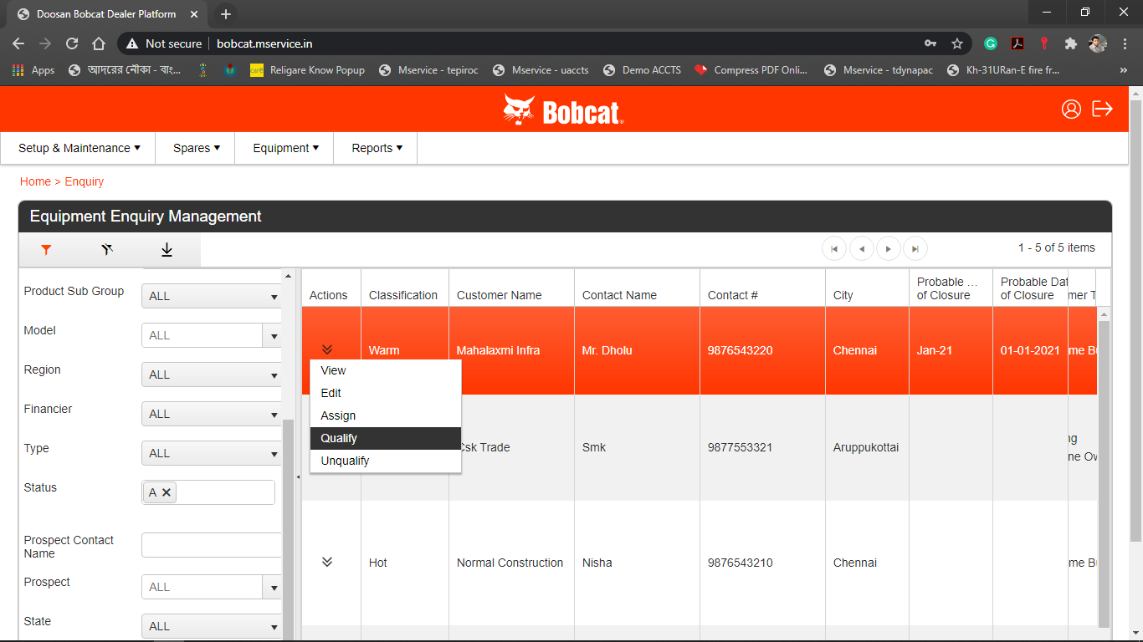

Sales Manager can enter comments if any in the dialogue box & submit.
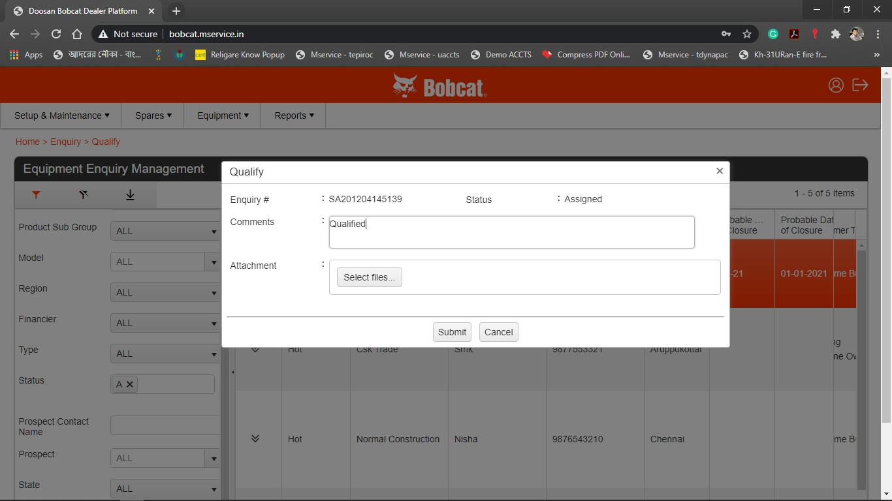
Then the qualified entries will be shown in the sales engineer’s mobile app under My Tasks. The enquiry status is now changed from Assigned to Qualified as seen in the below image.
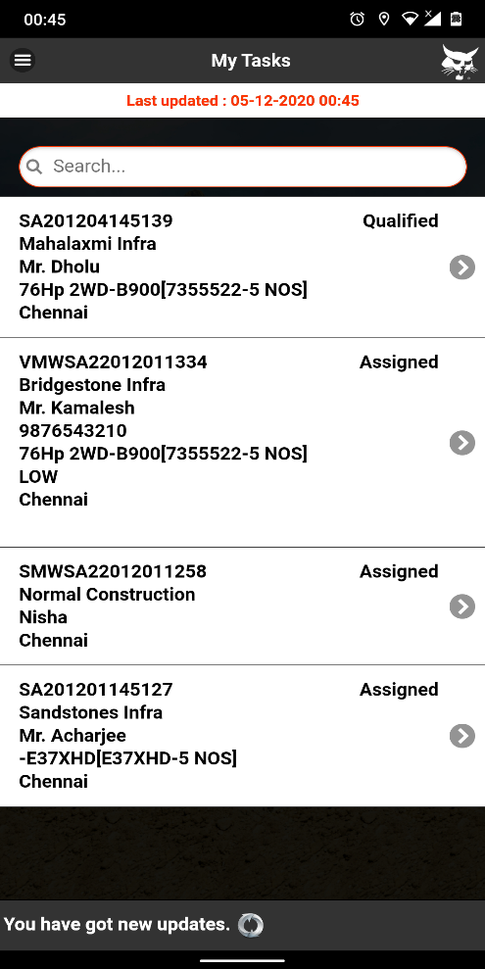

By clicking on Progress Update , the sales engineer can update his activities (Such as Quote submit, Advance received, FI Done, Financier Case In, PI Given, DO Received, Order Lost) done for the enquiry & also can up upload the picture from Attachment option if any document available for that action. Any comment can be given the same time. The Sales Coordinator can check the engineer’s activities & engineer’s comments from his/her WEB login & change the enquiry status.
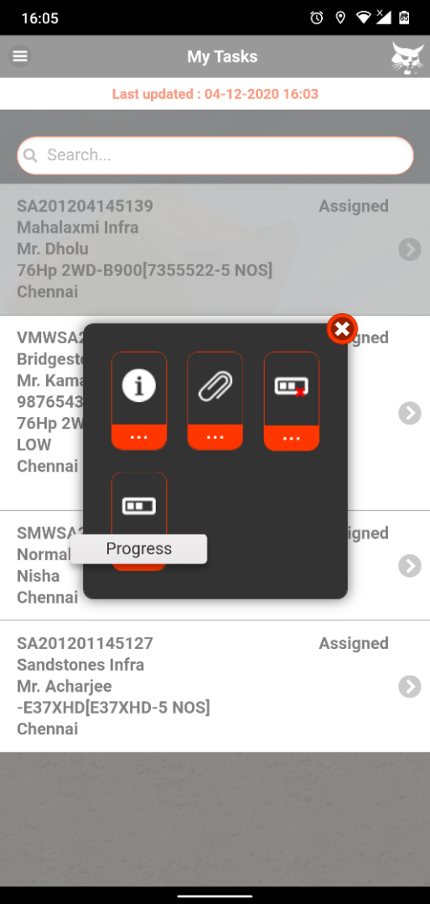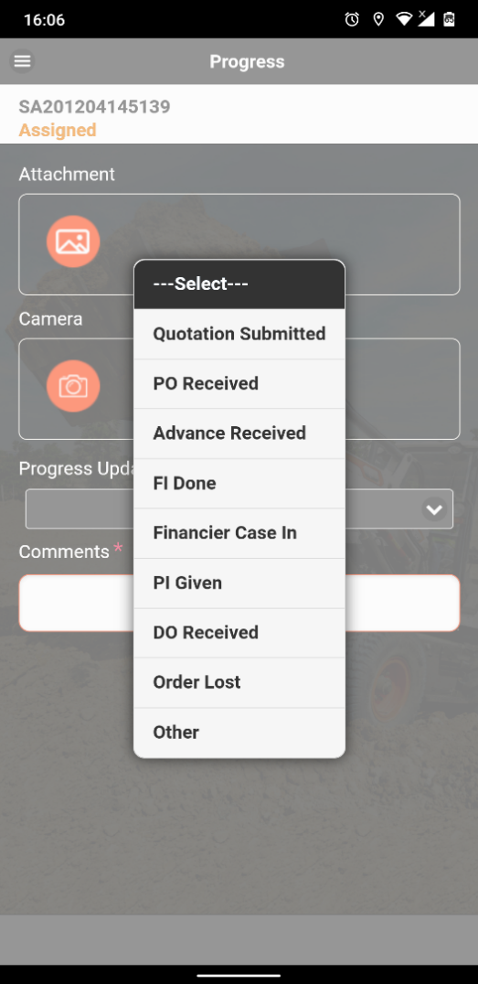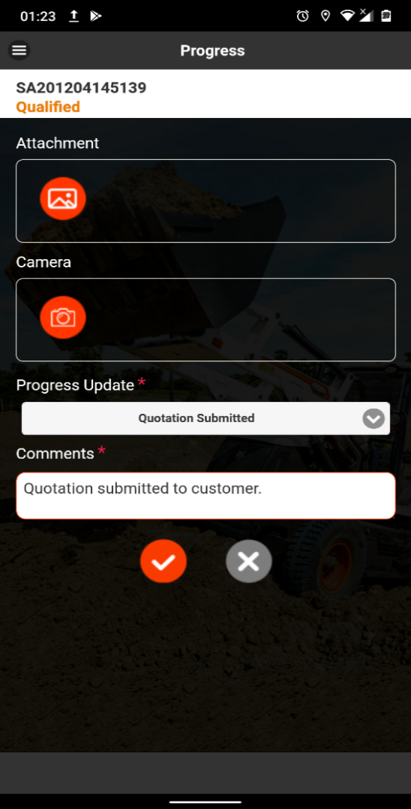
The After the Progress Update by the Sales Engineer, the Sales Coordinator will login through the web & update the enquiry status.
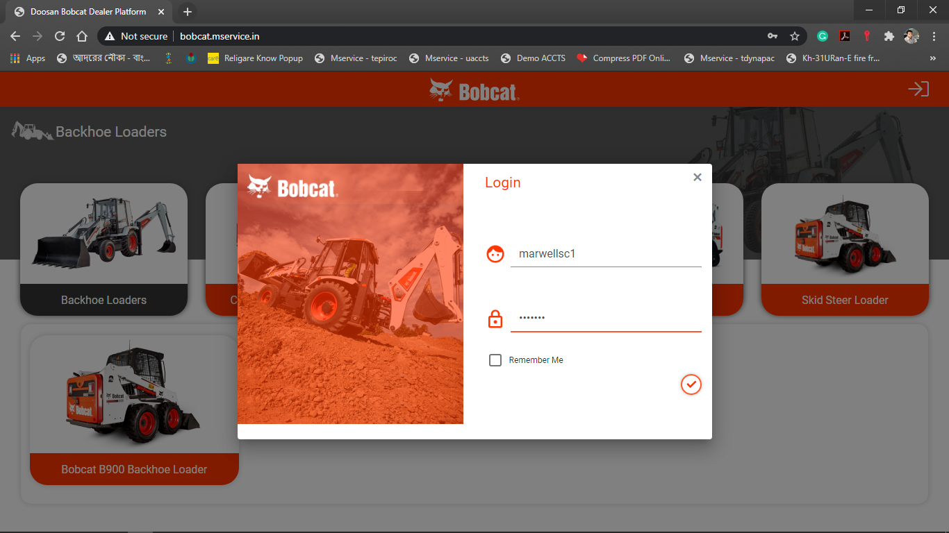
After the logging, the sales coordinator will view the comments given in the enquiry by the sales Engineer & update the relevant status from the action button. By this way, the sales coordinator can change the enquiry status till Billing Done & each status update by the sales coordinator will be visible in sales engineer’s mobile app as well.
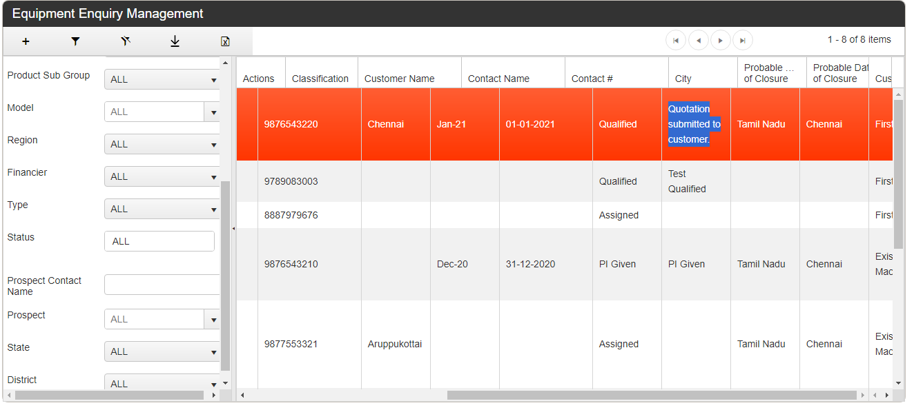

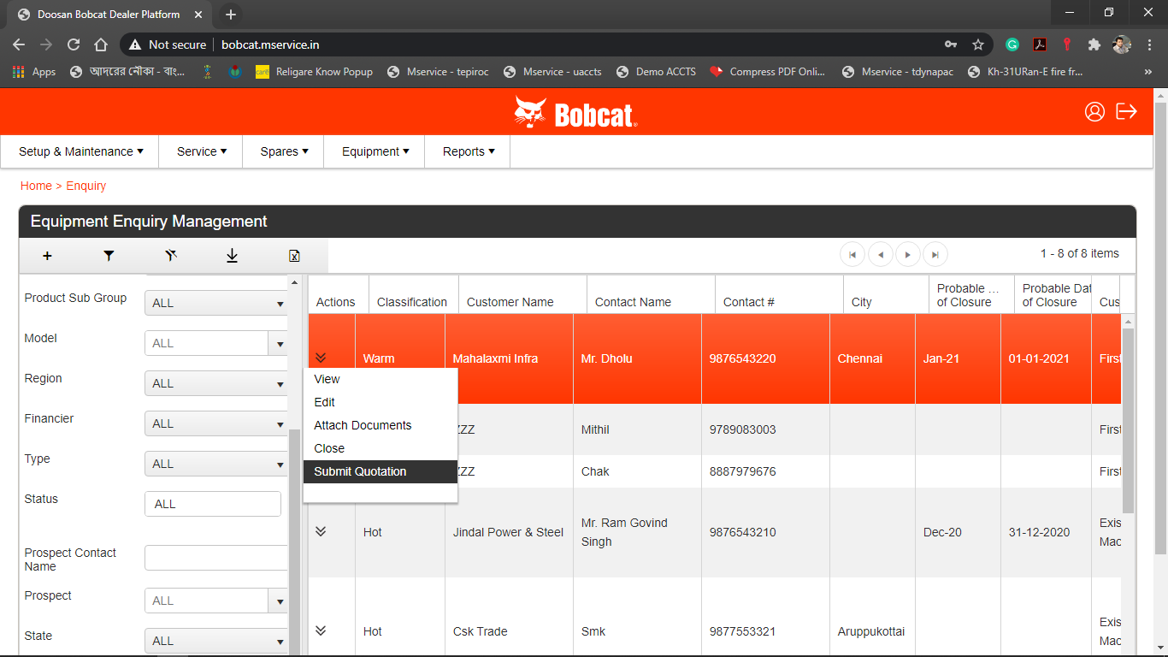


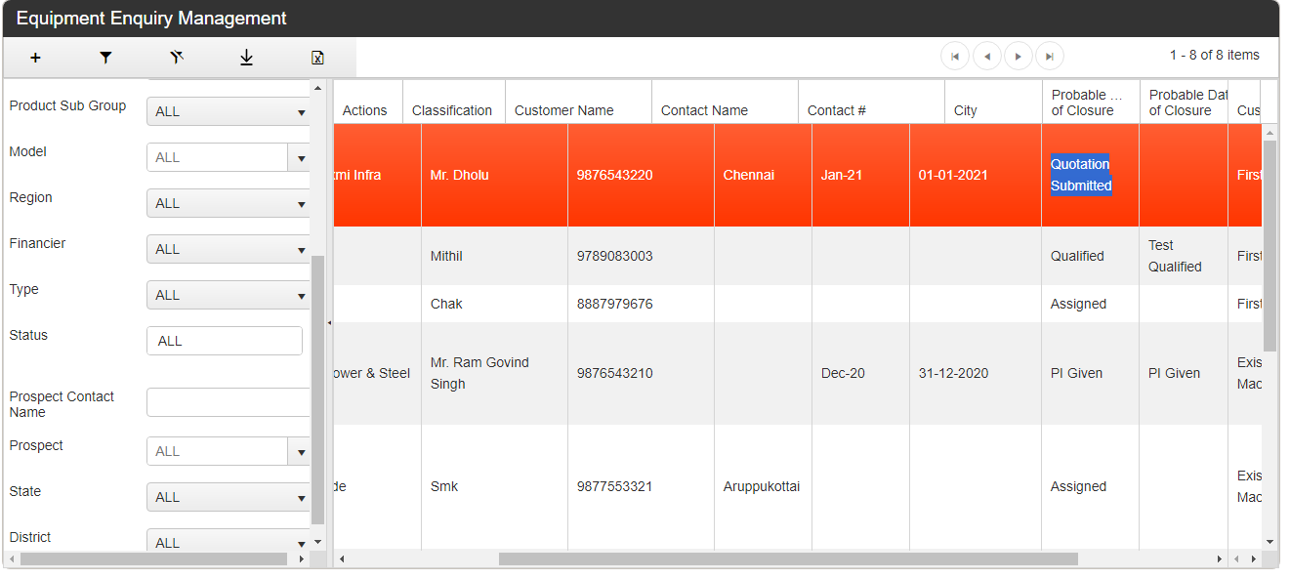
As shown in the above images, the Sales Coordinator has changed the Enquiry status from Qualified to Quotation Submitted after information received from sales engineer’s comments. As the same status change is reflecting in Sales Engineer’s mobile app as well.
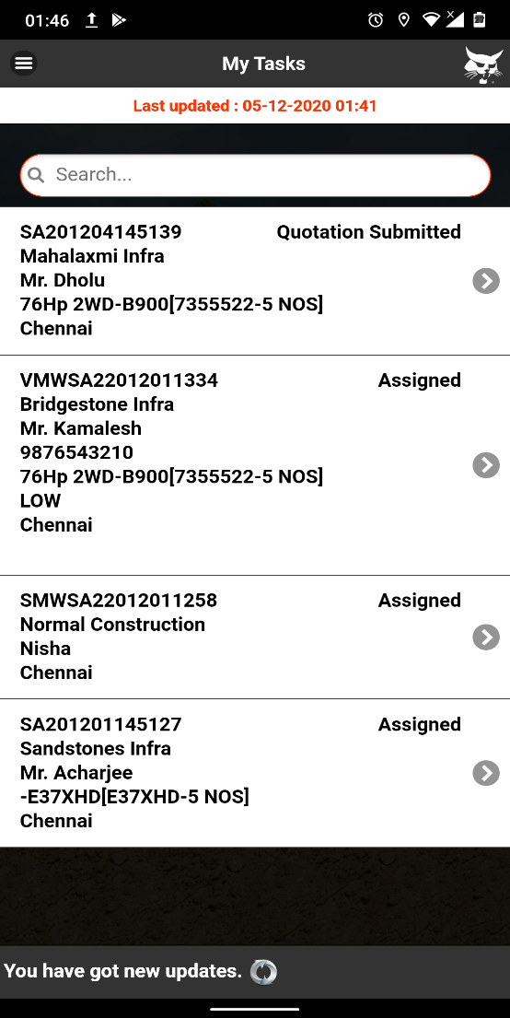
The Sales Engineer can also update the status as No Movement if there is no progress made for the enquiry for the day.
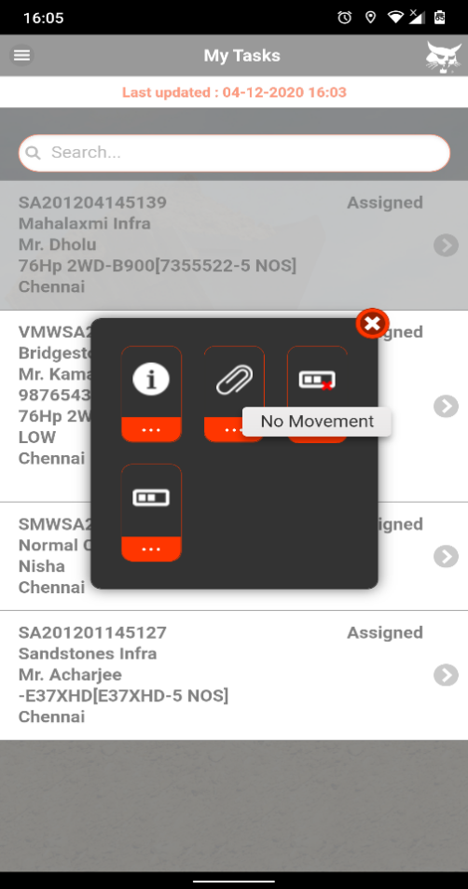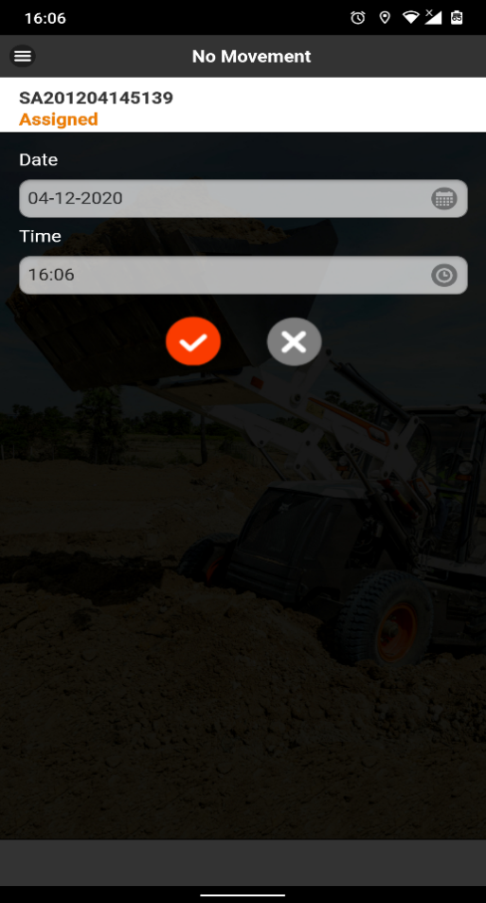
In case of Order Lost informed by the Sales Engineer, the Sales Coordinator has to mention the Lost Quantity, Reason, Competitor Name, Competitor OEM Model & comments if any in the Order Lost screen in the web. After the Billing Done/Oder Lost, the completed enquiry cannot be seen in My Task of Sales Engineer’s mobile app.
Please Note: Order Lost option will be available before DO Received in Sales Coordinator login. (Please see the app flow given in page no.02 for reference)
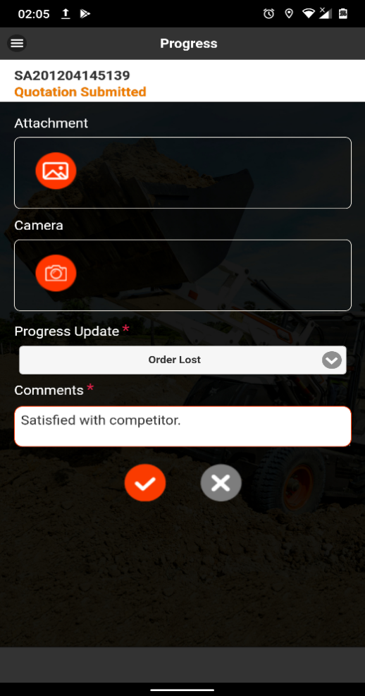

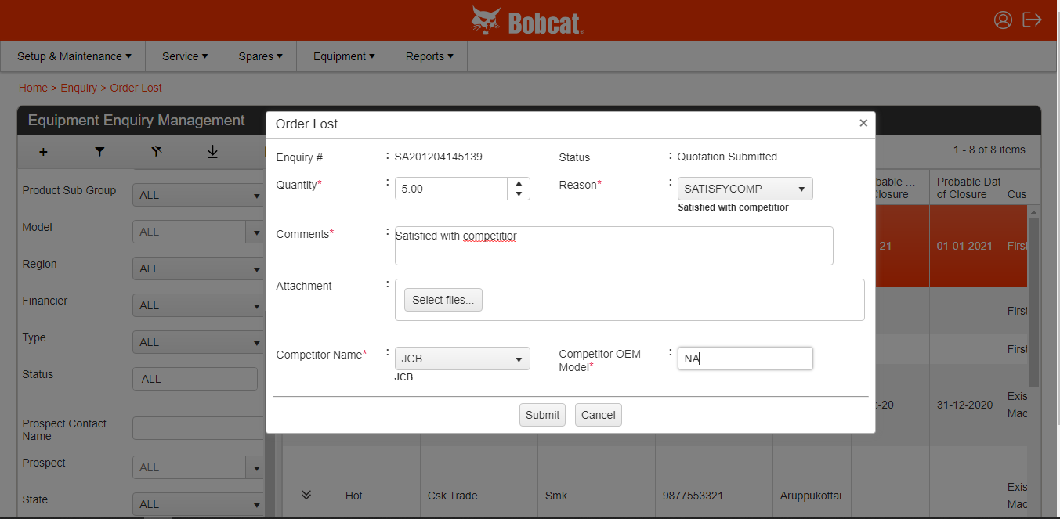

The Sales Engineer can directly log an enquiry from Enquiry Logging option given in the mobile app for an existing customer.
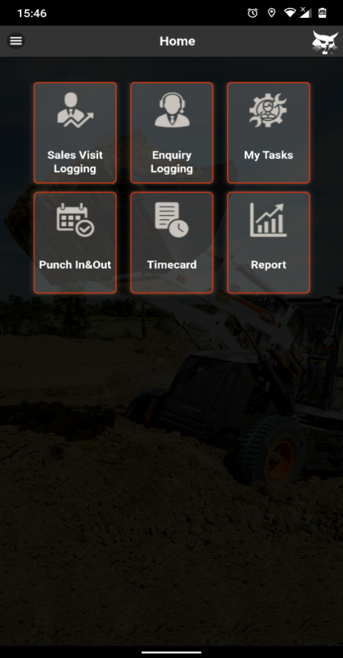
The sales engineer has to fill up an Enquiry Logging form similar to the Meeting Report. After tagging the location in the 1st page of that form, engineer has to search & select the customer. Engineer can search the customer by typing the customer name or the customer id in the Prospect Name field & relevant customer names will appear in drop down. Then the engineer needs to select the customer name from the drop down.
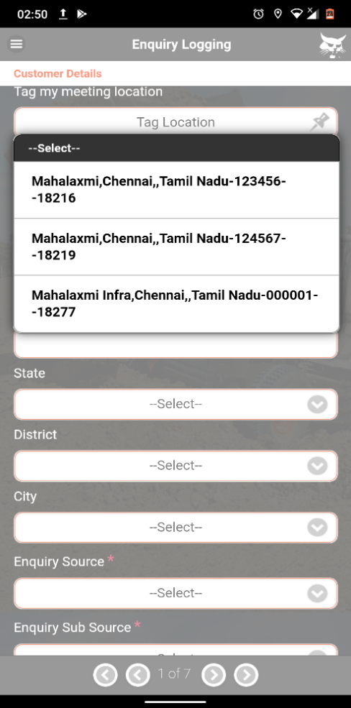
Also the sales engineer has to mention the Enquiry Source & Enquiry Sub-Source from the drop down in the 1st page. From the 2nd page, the sales engineer has to fill up the requirement details similar to the Meeting Report.
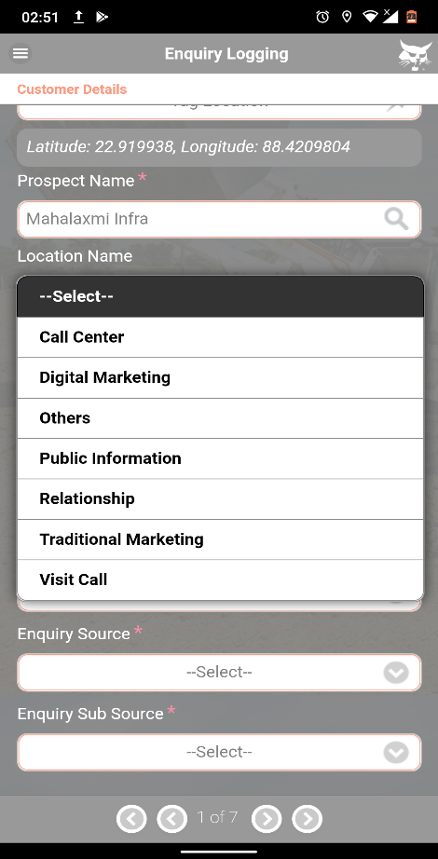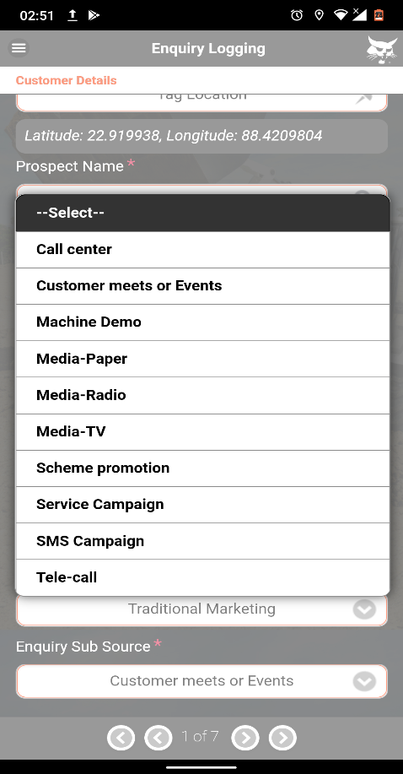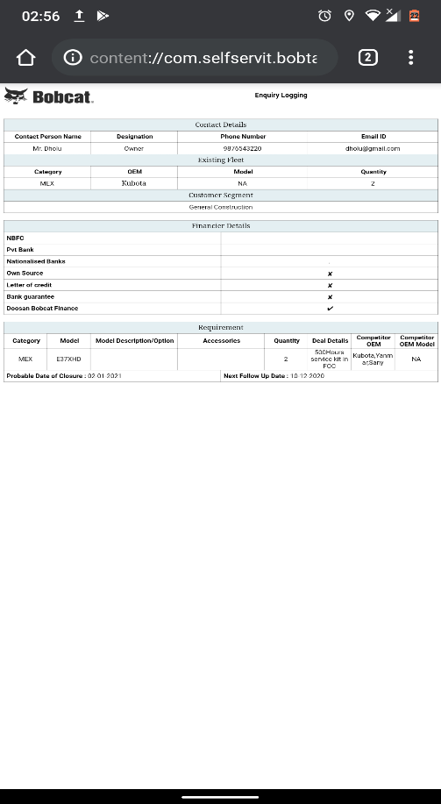
After submission of enquiry details, an Enquiry number will get generated & auto-assigned to the Sales Engineer. The newly generated enquiry can be found under My Tasks starting with SMW (S-for Sales & Dealer code Eg. Marwell: MW). After getting Qualified by the dealer sales manager, the sales engineer can update his activities from Progress Update option & the sales coordinator can change the enquiry status till Billing done or can do Order Lost.
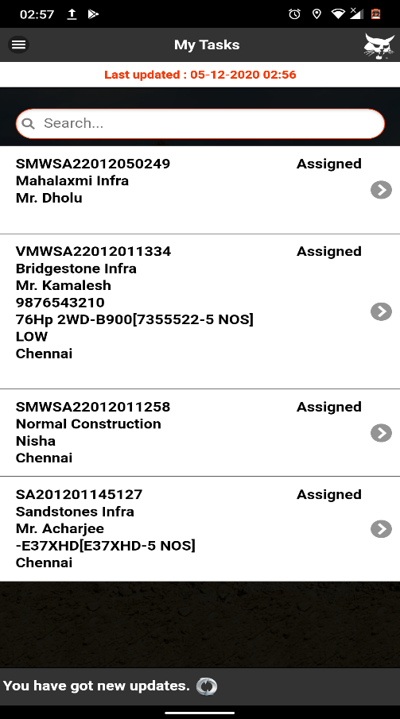

The

T

